Henfield Medical Centre

Chaperone Leaflet

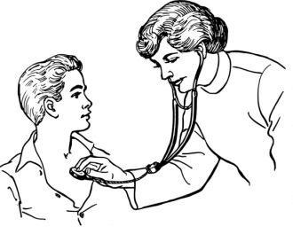

Henfield Medical Centre is committed to developing a culture within the organisation that promotes and champions the privacy and dignity of all patients.
It is recognised that how care is delivered is vitally important to self-confidence. Some health care interactions and treatments, particularly where they involve intimate parts of the body and state of undress, can make patients feel vulnerable or distressed. The presence of a chaperone may assist in supporting and reassuring the patient during the healthcare interaction.

The healthcare professional may also require a chaperone to be present for certain consultations in accordance with the practices Chaperone Policy.

We believe respect, explanation, consent and privacy are paramount to ensuring you receive a positive patient experience.

What to expect
You should expect to be offered a chaperone for any intimate examinations that are requested as part of your treatment plan. You can request a chaperone is present during any health interaction that you feel uncomfortable with. Expect the role of the chaperone to be clearly explained to you and the person introduced to you by the health professional who is to undertake the health care examination.

Who can be a chaperone?
A member of staff can be a chaperone, such as a nurse, HCA or other trained non-clinical staff member. All staff acting as chaperones within the practice has been trained and DBS checked.

Can a family member act as a chaperone?
Your family member cannot act as a formal chaperone. You can however request that a member of your family or a friend be present as an informal chaperone during the examination, procedure. A situation where this may not be appropriate is where a child is asked to act as a chaperone for a parent undergoing an intimate examination.

Can I refuse a chaperone?
You have the right to refuse a particular person as a chaperone; in this instance a member of staff will document the reasons for your refusal and your health interaction will be reviewed.
In all cases where the presence of a chaperone may intrude in a confidential clinician-patient discussion their presence will be confined to the physical examination. One-to-one communication between the patient and their clinician can continue afterwards.

What is the chaperones responsibility?
- Ensure that conduct is sensitive and respectful of your dignity and confidentiality
- To reassure you if you are distressed or experiencing discomfort and to communicate this to the member of staff undertaking the procedure
- Ensure that they can communicate with you in a way that you can understand

What if a chaperone cannot be offered?
If in the unlikely event a chaperone cannot be offered because of staff availability then expect to be informed. You may be asked in this instance to delay the interaction unless this is likely to be detrimental to your health

